Exp 38

AIM: Design NFA using simulator to accept the input string “bbc” ,”c”,and ”bcaaa

INPUT:

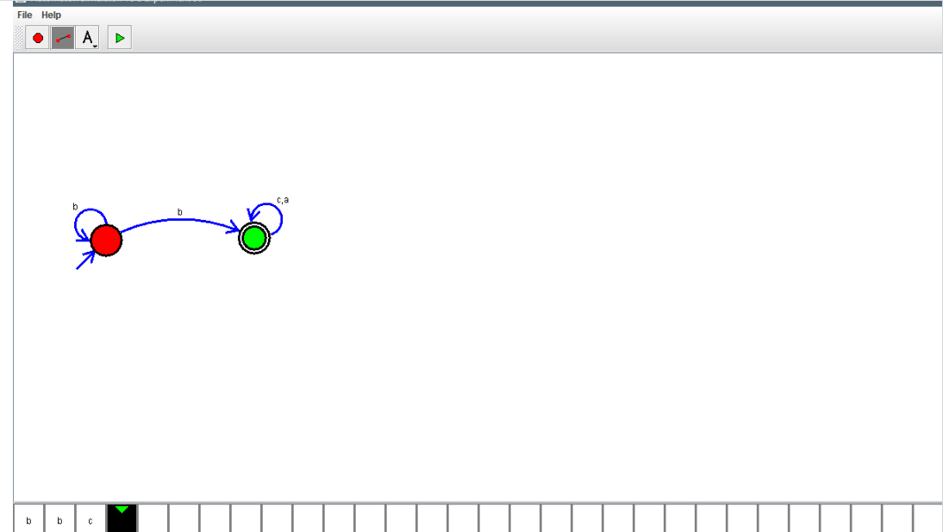

OUTPUT:



RESULT: Design NFA using simulator to accept the input string “bbc” ,”c”,and ”bcaaa is verified